

Assignment-1
Web Engineering

- Submitter By : Muhammad Essa
- Submitter To : Mr Azhar ALi
- Subject : Web Engineering
- Semester : 6th
- Section : ( A )
- Department : BSCS
- Registration No : 2023-KIU-BS5215

https://github.com/MuhammadEssa-514/Web-Engineering-Course
visit above link for repository to check assignment code
https://muhammadessa514.vercel.app
visit portfolio


- Html Basic Structure of boiler plate

- <!DOCTYPE html>

- This is a mandatory declaration at the very top of the document that tells the browser the page is written in HTML5.If we don't include this declaration, the browser will assume the page is written in an older version of HTML.

- <html>

- The html tag is the root element becauew it act as a container for other elements and tell the browser every thing inside this tag is html

- <head>
- A container for metadata (data about the page). This information is not visible to users but is crucial for browsers and search engines.

- <body>

- This contains all the visible content, such as text, images,buttons etc.

- IDE SS Assignment with simple Css for clear tags visibility
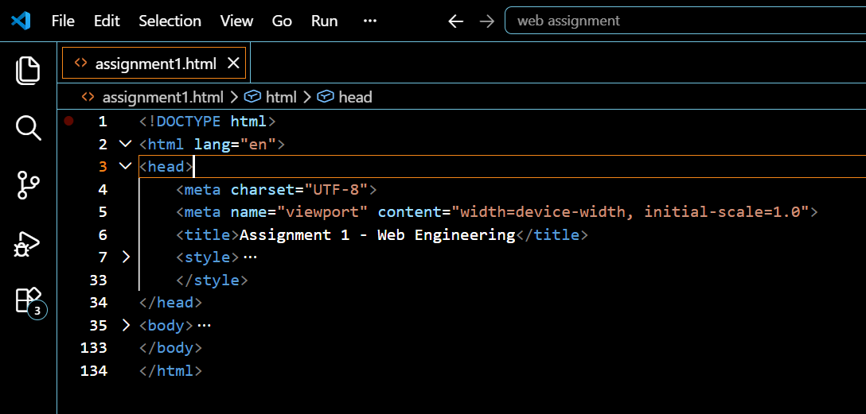

- 2-Html Web Structure

• Navbar contain main links of pages for switching or redirecting to other page or web.

• Body. Contain all other content which is visible for users like text,image,videos and buttons etc.

• footer.botton section of web contain social links ,maps ,contact info, copy right 2notice and privacy policies.

- Check basic web structure visit repo for checking practically

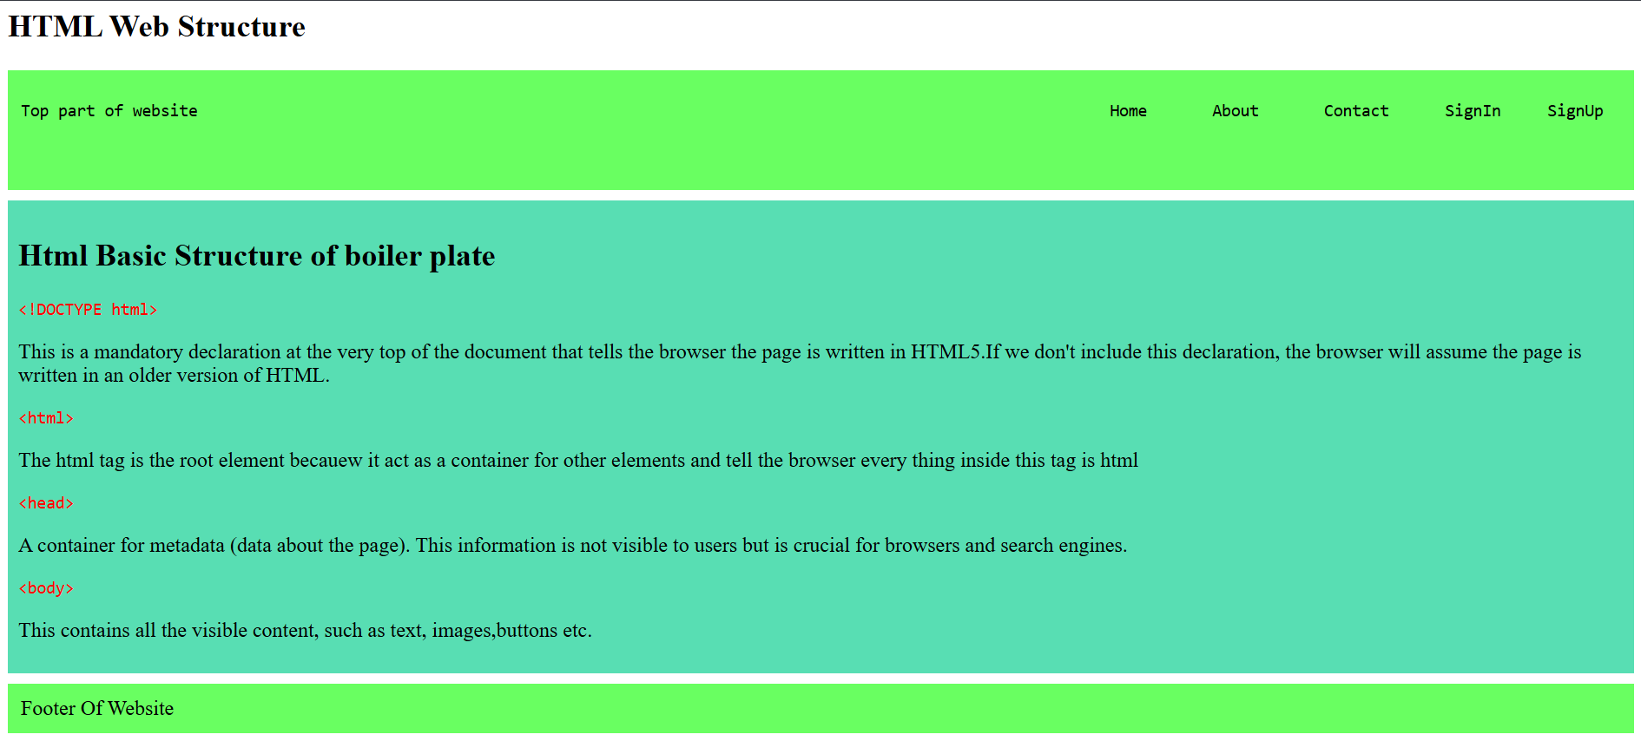

- Semantic Elements

- Semantic Elements
- Semantic elements are those elements that clearly describe their meaning and purpose for both the browser and the developer

- Check SS of Semantic element visit repo for checking practically
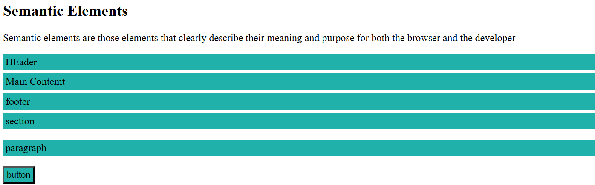

- Block Elements

- Block Elements:
A block-level element is a type of element that structures a web page by taking up the full width available and always starting on a new line.

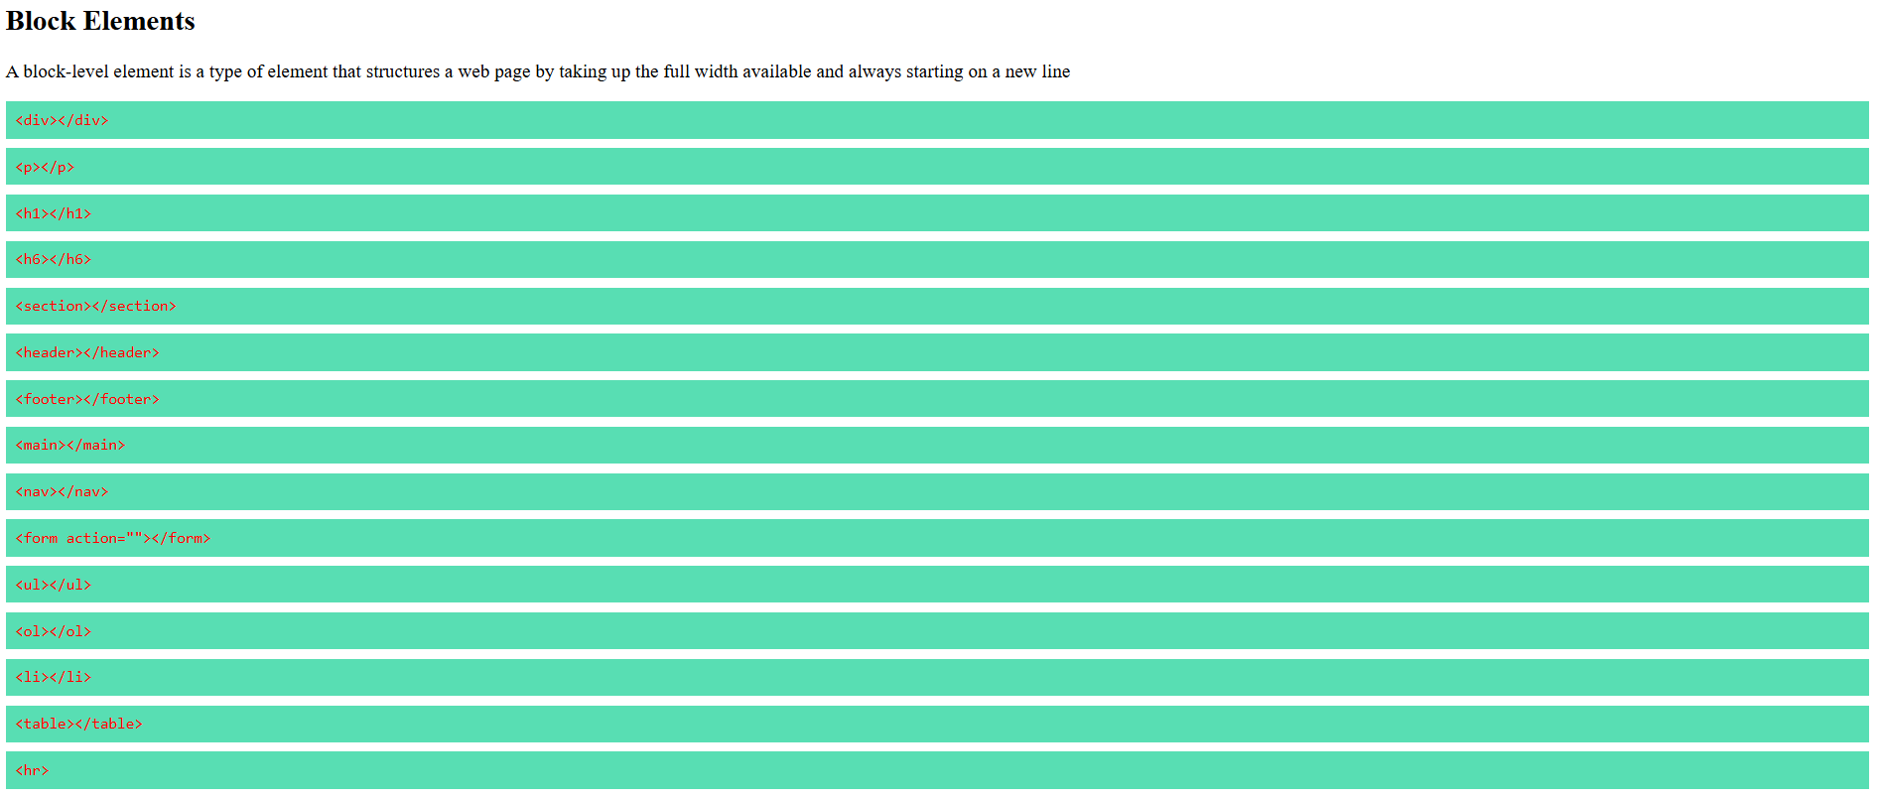
- Inline Elements

- Inline Elements:
- An inline element is a type of element that does not start on a new line and only takes necessary space for its content
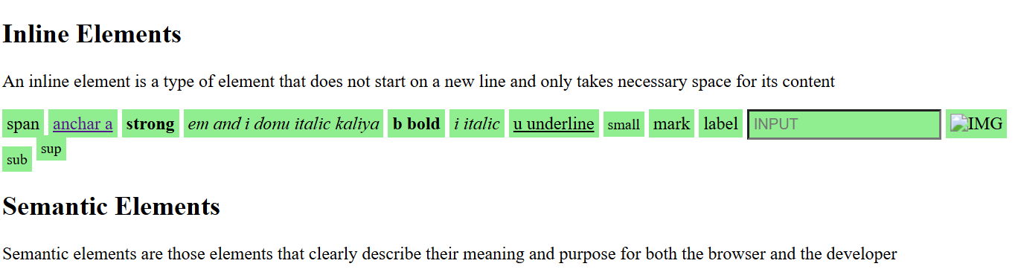

Assignment 1 with Simple Css-code
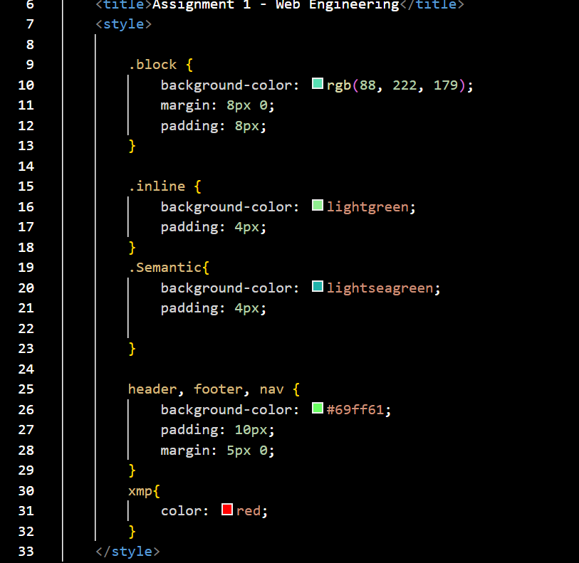 | 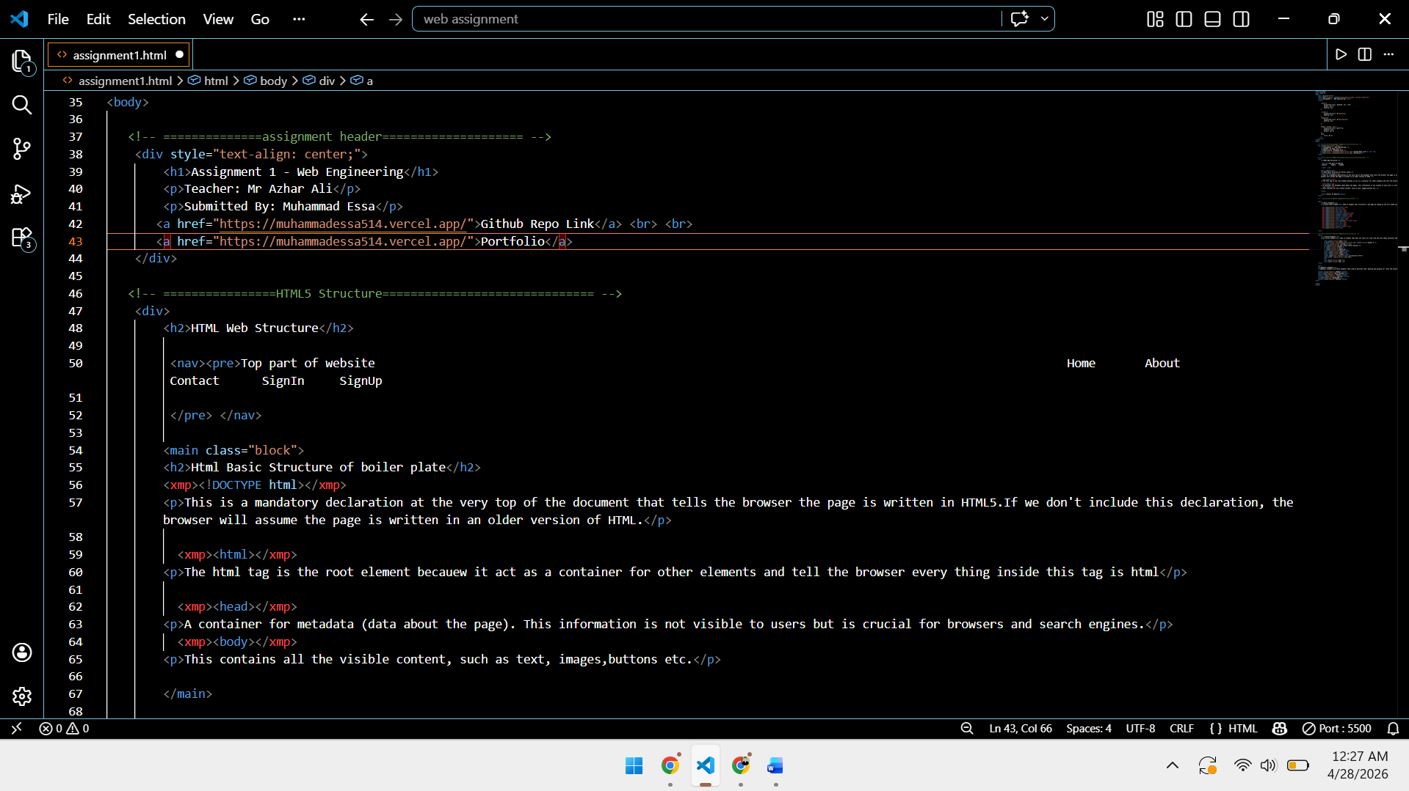
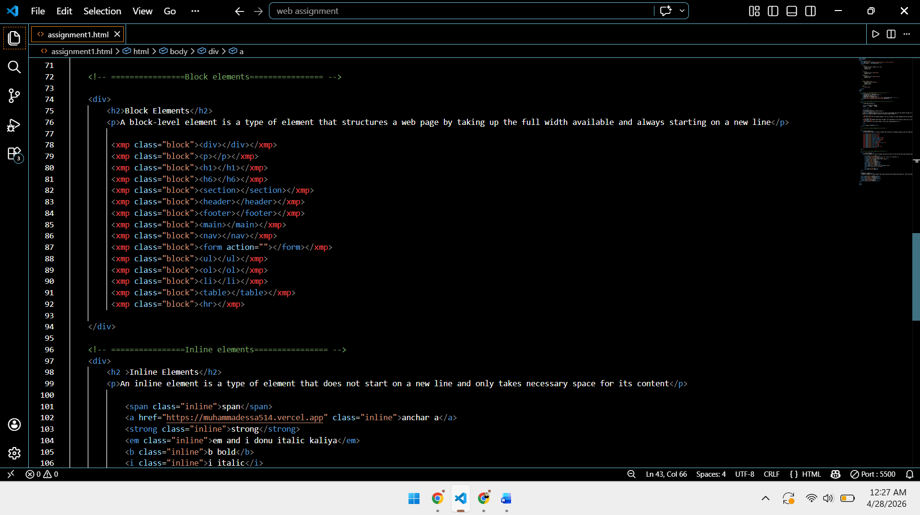 | 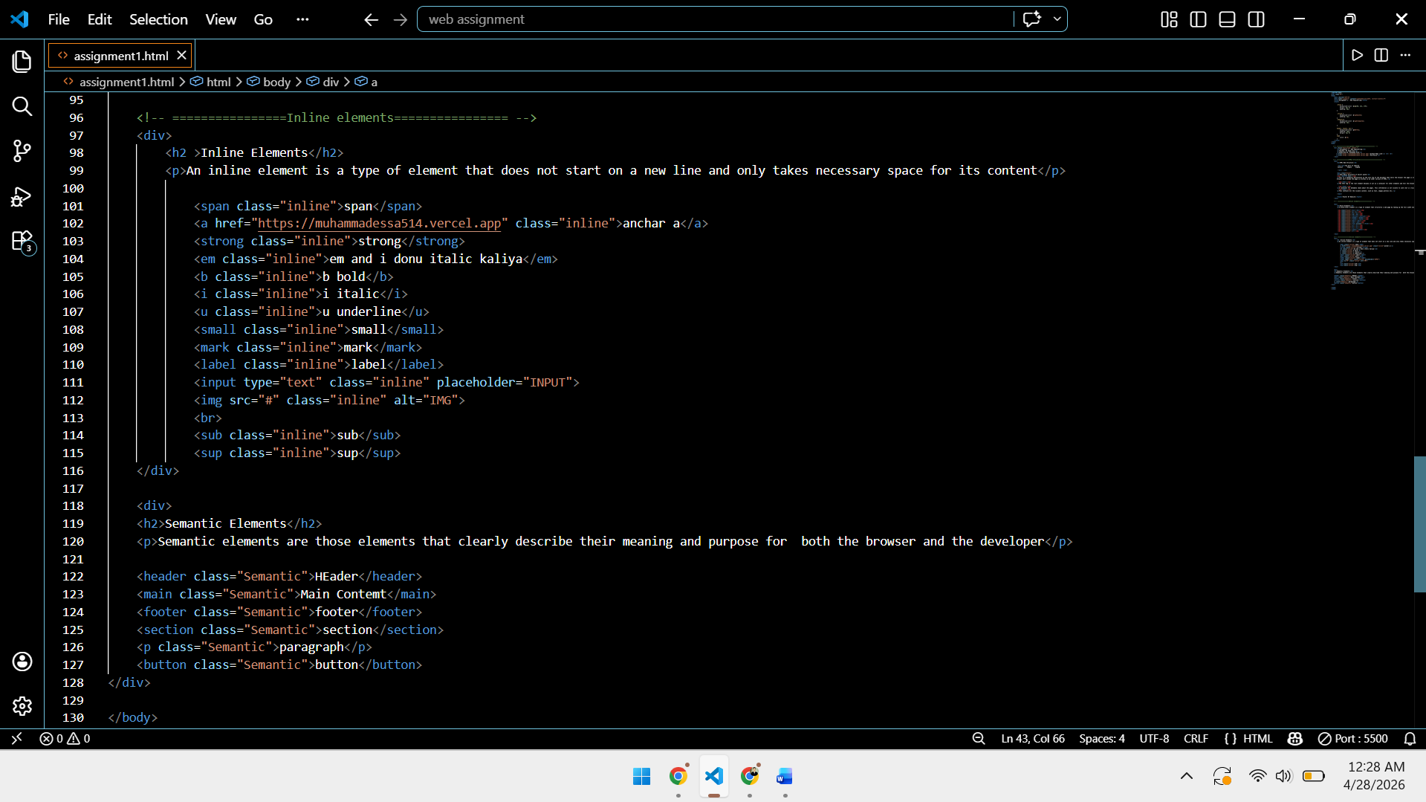

=====Assignment 1 without Css-code====
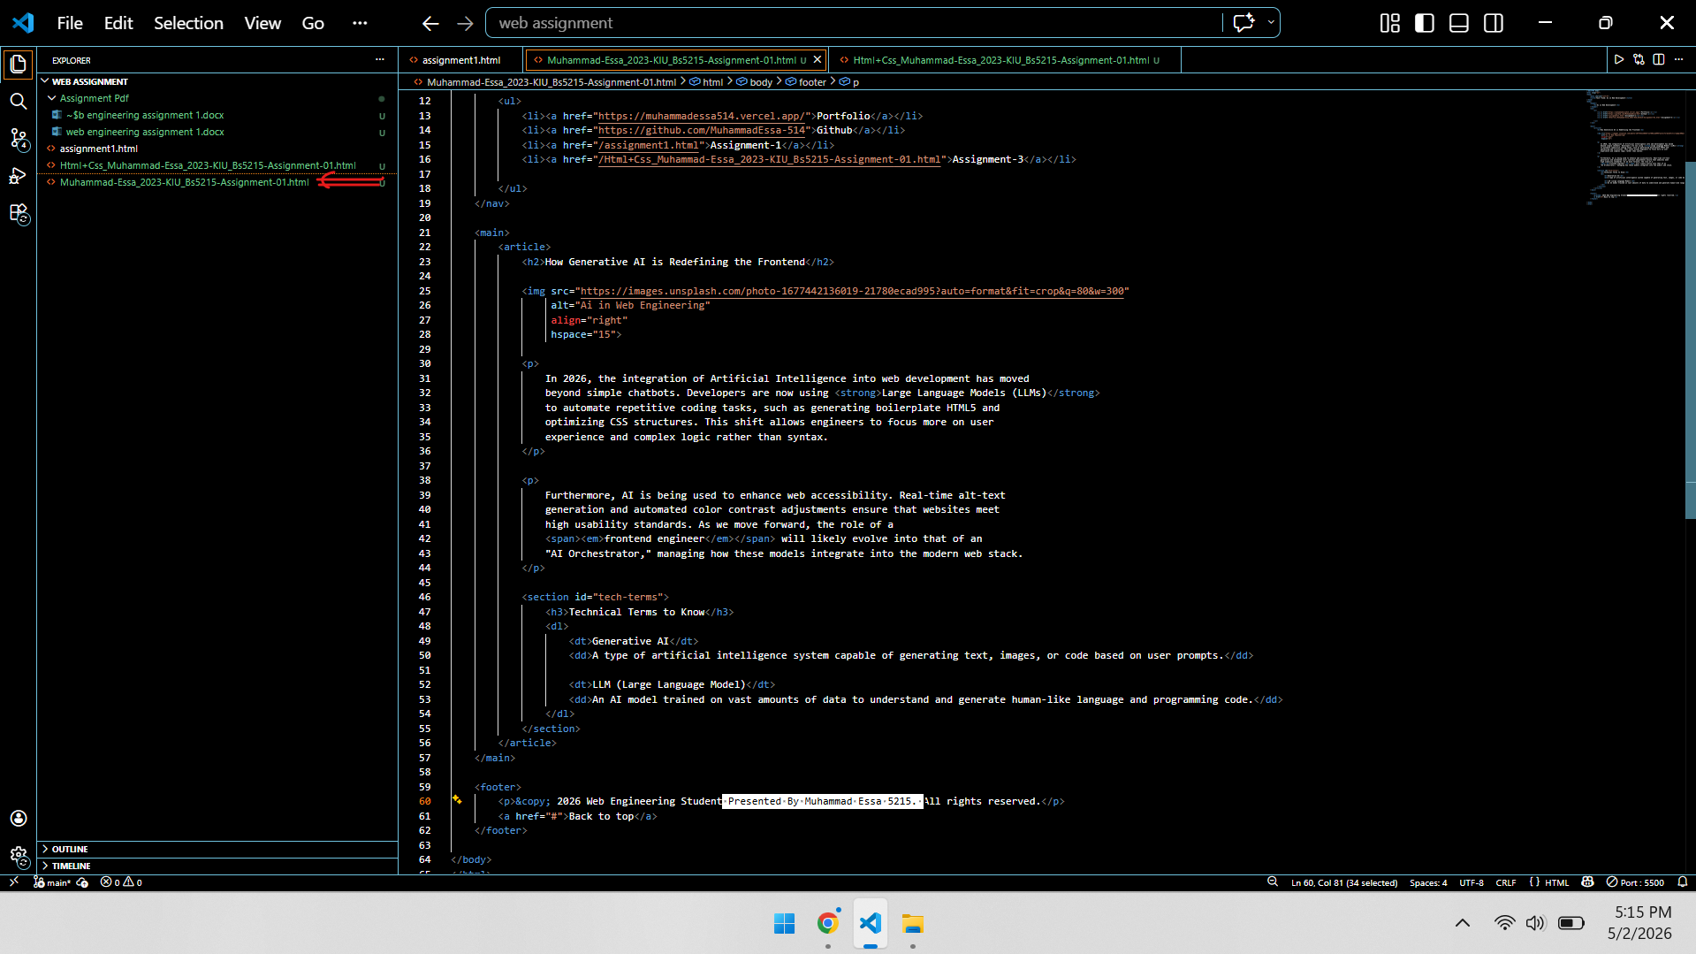

=Assignment 1 without Css-code Output=
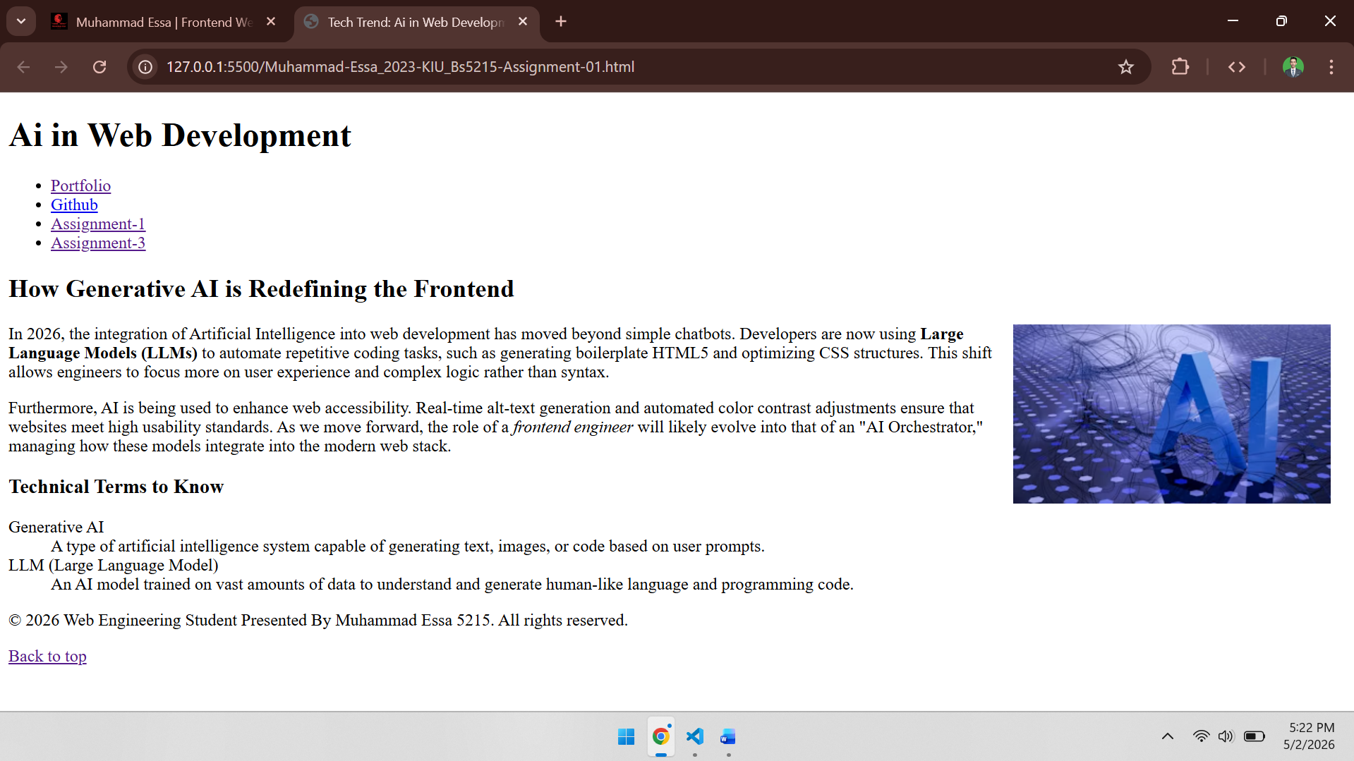
===Assignment 1 with Proper Css-code===

=Assignment 1 with Proper Css Output=
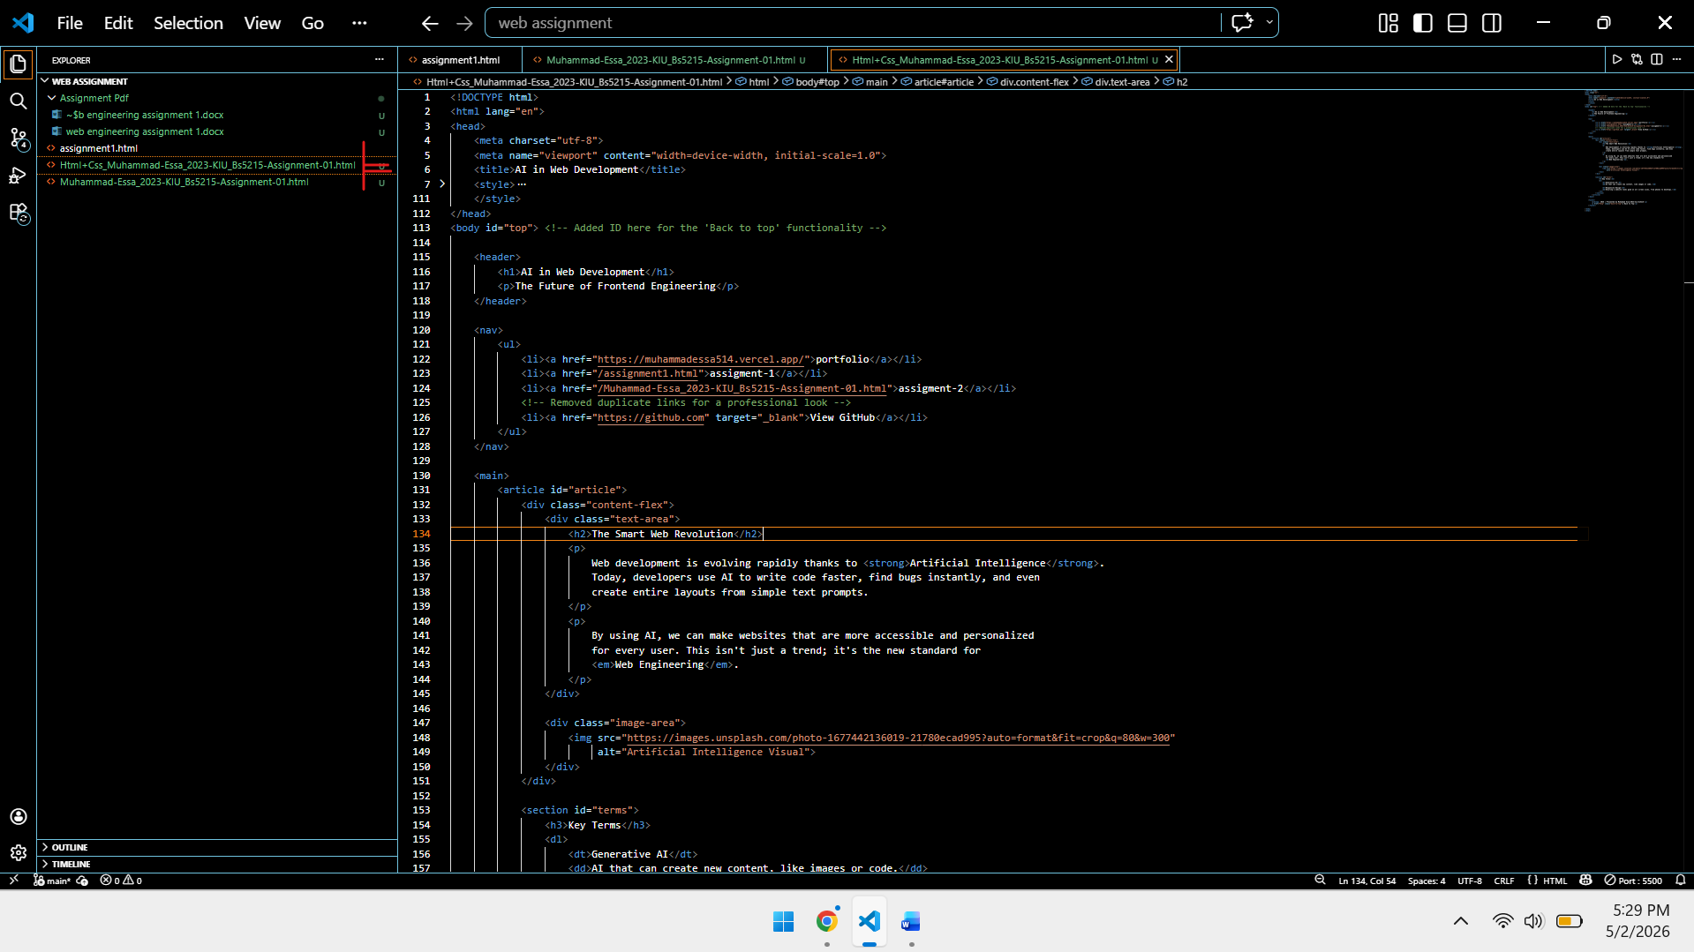

Thanks Mr Azhar Ali

